Name: ____________________________________ Per: ______ Date:__________________
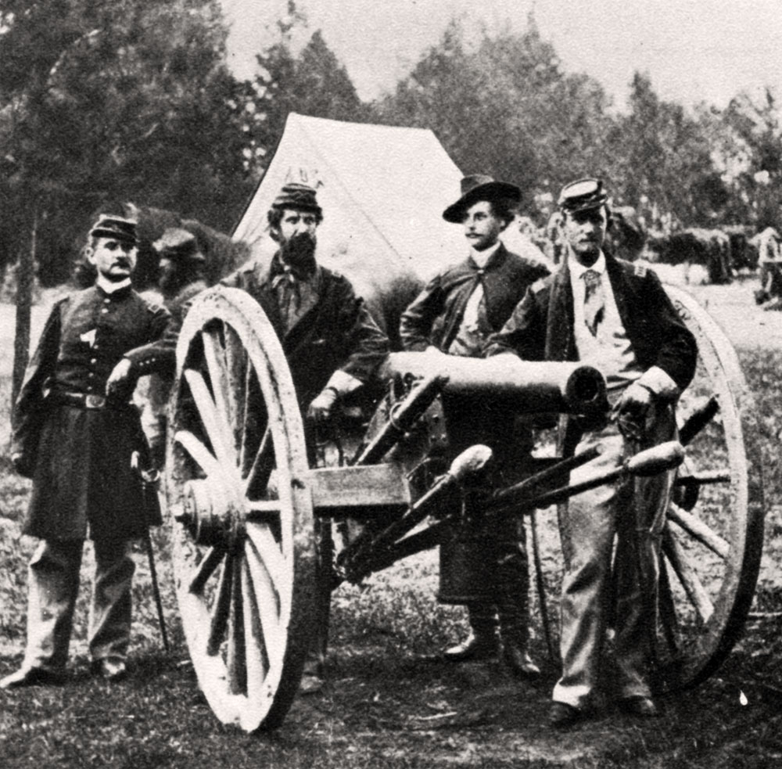
Toward Civil War – Student Notes
Events and Issues that led to the Civil War

Missouri Compromise

Causes
__________________________________________________________
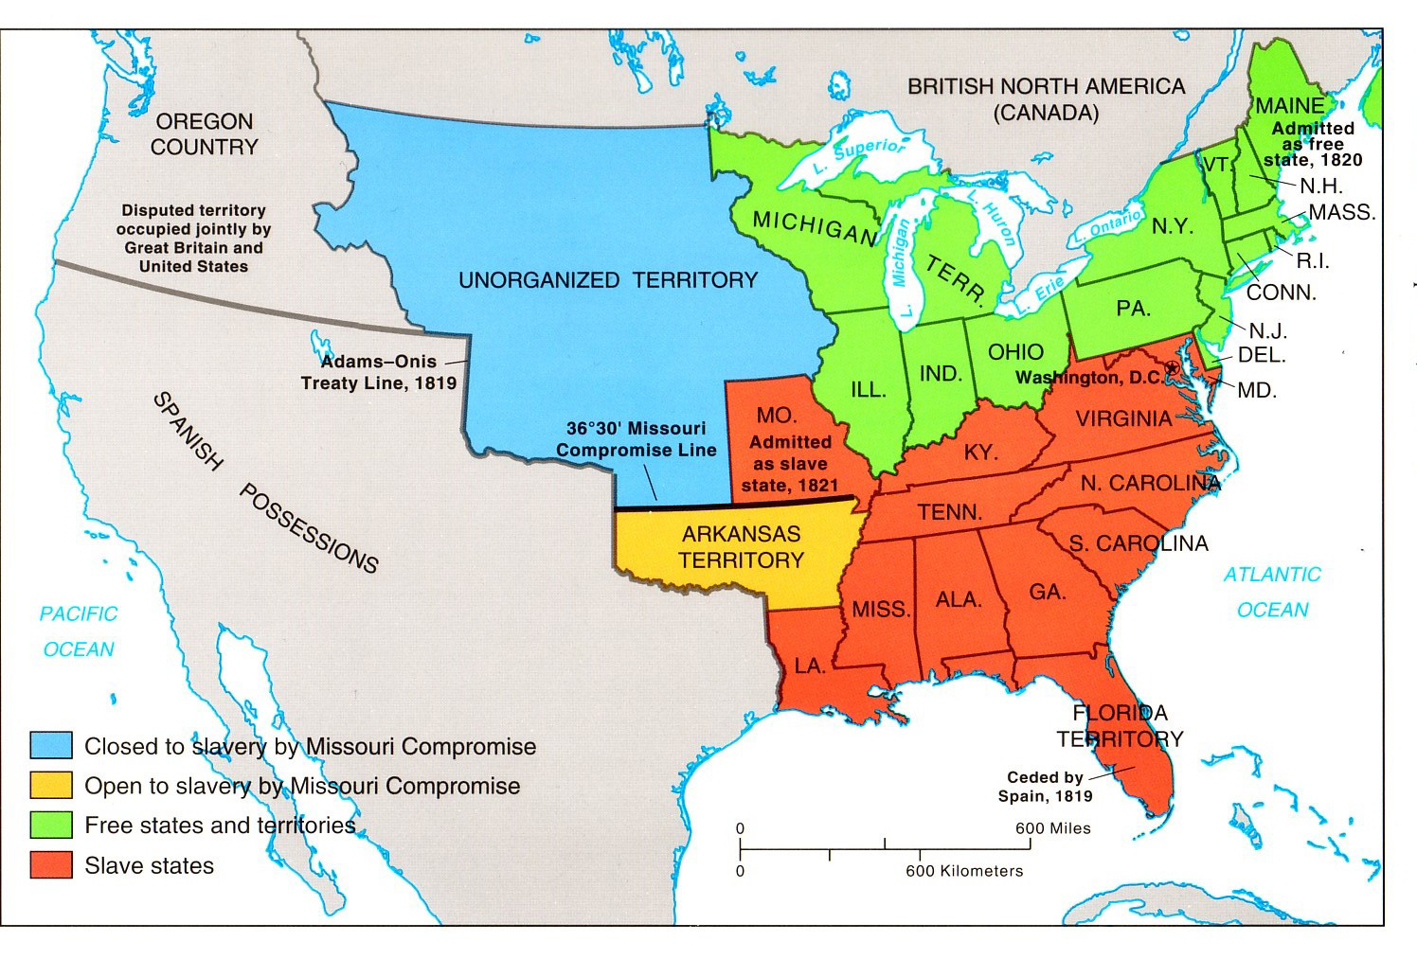
__________________________________________________________
__________________________________________________________
__________________________________________________________
__________________________________________________________

What happened? (3 parts to the Compromise)
__________________________________________________________
__________________________________________________________
_________________________________

Major Players Effects
____________________________ __________________________
____________________________ __________________________
____________________________ __________________________

Compromise of 1850
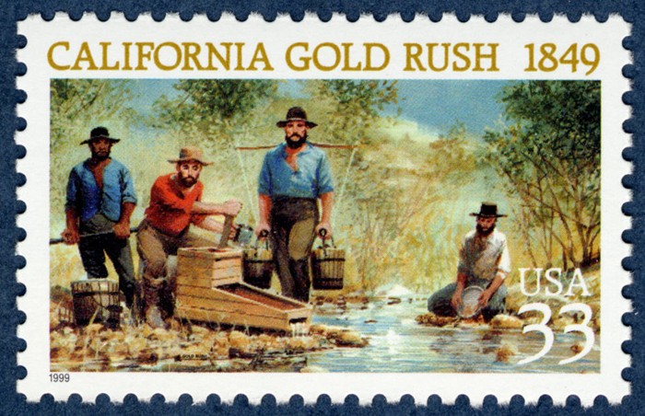

Causes
__________________________________________________________
__________________________________________________________

South Gained:
- _________________________________

- _________________________________

- __________________________________

North Gained:
- _________________________________

- _________________________________

- __________________________________

What happened?
__________________________________________________________
__________________________________________________________

Major Players Effects
____________________________ __________________________
____________________________ __________________________
____________________________ __________________________

Abolitionists and Underground Railroad
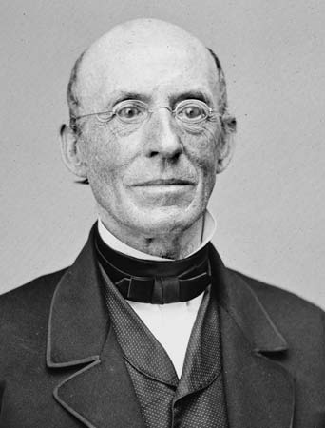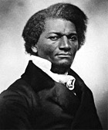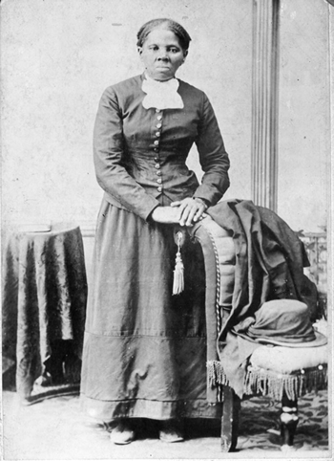

What is the goal of the abolitionists? and Who are they?
__________________________________________________________
__________________________________________________________
__________________________________________________________
__________________________________________________________

What is the Underground Railroad?
__________________________________________________________
__________________________________________________________
__________________________________________________________

Major Players Effects
____________________________ __________________________
____________________________ __________________________
____________________________ __________________________
____________________________ __________________________

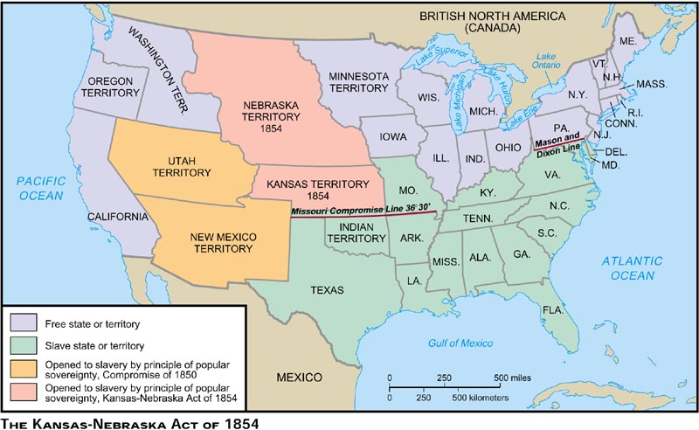
Kansas-Nebraska Act (and Bleeding Kansas)

Causes
__________________________________________________________
__________________________________________________________
__________________________________________________________

THE LAW (Popular Sovereignty)
__________________________________________________________
__________________________________________________________

What happened? __________________________________________________________
__________________________________________________________

Major Players Effects (Bleeding Kansas)
____________________________ __________________________
____________________________ __________________________
____________________________ __________________________
____________________________ __________________________
Scott v. Sandford (Dred Scott Case)
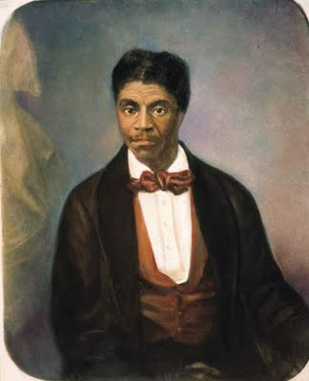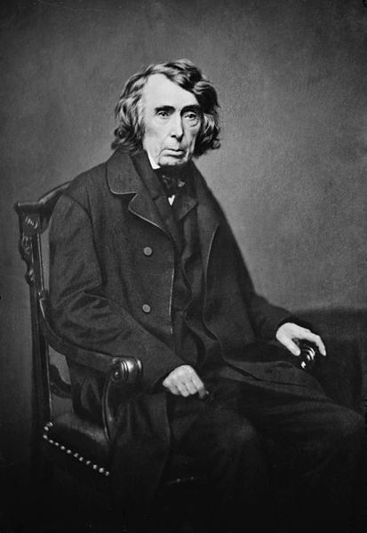

The Supreme Court Case (description)
__________________________________________________________
__________________________________________________________
__________________________________________________________

Major Players (Scott, abolitionists, Sandford, Taney)
- ____________________________________________________________________________________________________________________________

- ____________________________________________________________________________________________________________________________

- ____________________________________________________________________________________________________________________________

- ____________________________________________________________________________________________________________________________

Decision in the CASE Effects of the Case
____________________________ __________________________
____________________________ __________________________
____________________________ __________________________
____________________________ __________________________

John Brown and Harpers Ferry (Virginia in 1859 but today in West Virginia)
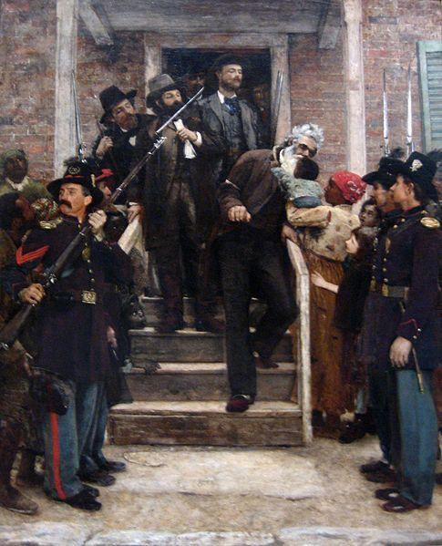
John Brown’s Plan
__________________________________________________________
__________________________________________________________
__________________________________________________________

What happened?
__________________________________________________________
__________________________________________________________
__________________________________________________________
__________________________________________________________

Major Players Effects
____________________________ __________________________
____________________________ __________________________
____________________________ __________________________
____________________________ __________________________
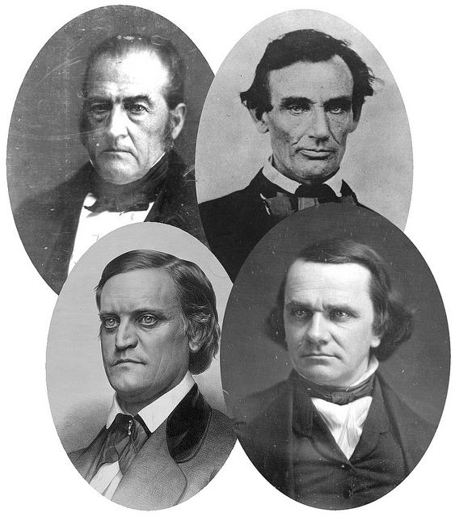
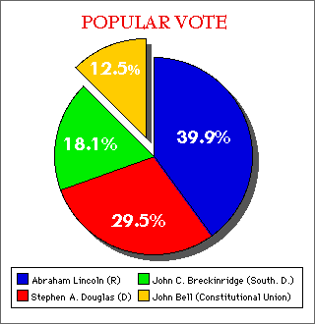
Election of 1860 (4 Candidates for Presid
Major Issues of the Election
__________________________________________________________
__________________________________________________________
__________________________________________________________

Major Players (Candidates, Party, Section of Nation)
______________________________________________________
______________________________________________________
______________________________________________________
______________________________________________________

What happened? Effects
_________________ __________________________
_________________ __________________________
_________________ __________________________
_________________ __________________________
_________________ __________________________
_________________ __________________________

Attack on Fort Sumter (located on an island in the harbor of Charleston, South Carolina)

What is Fort Sumter? Why is it important?
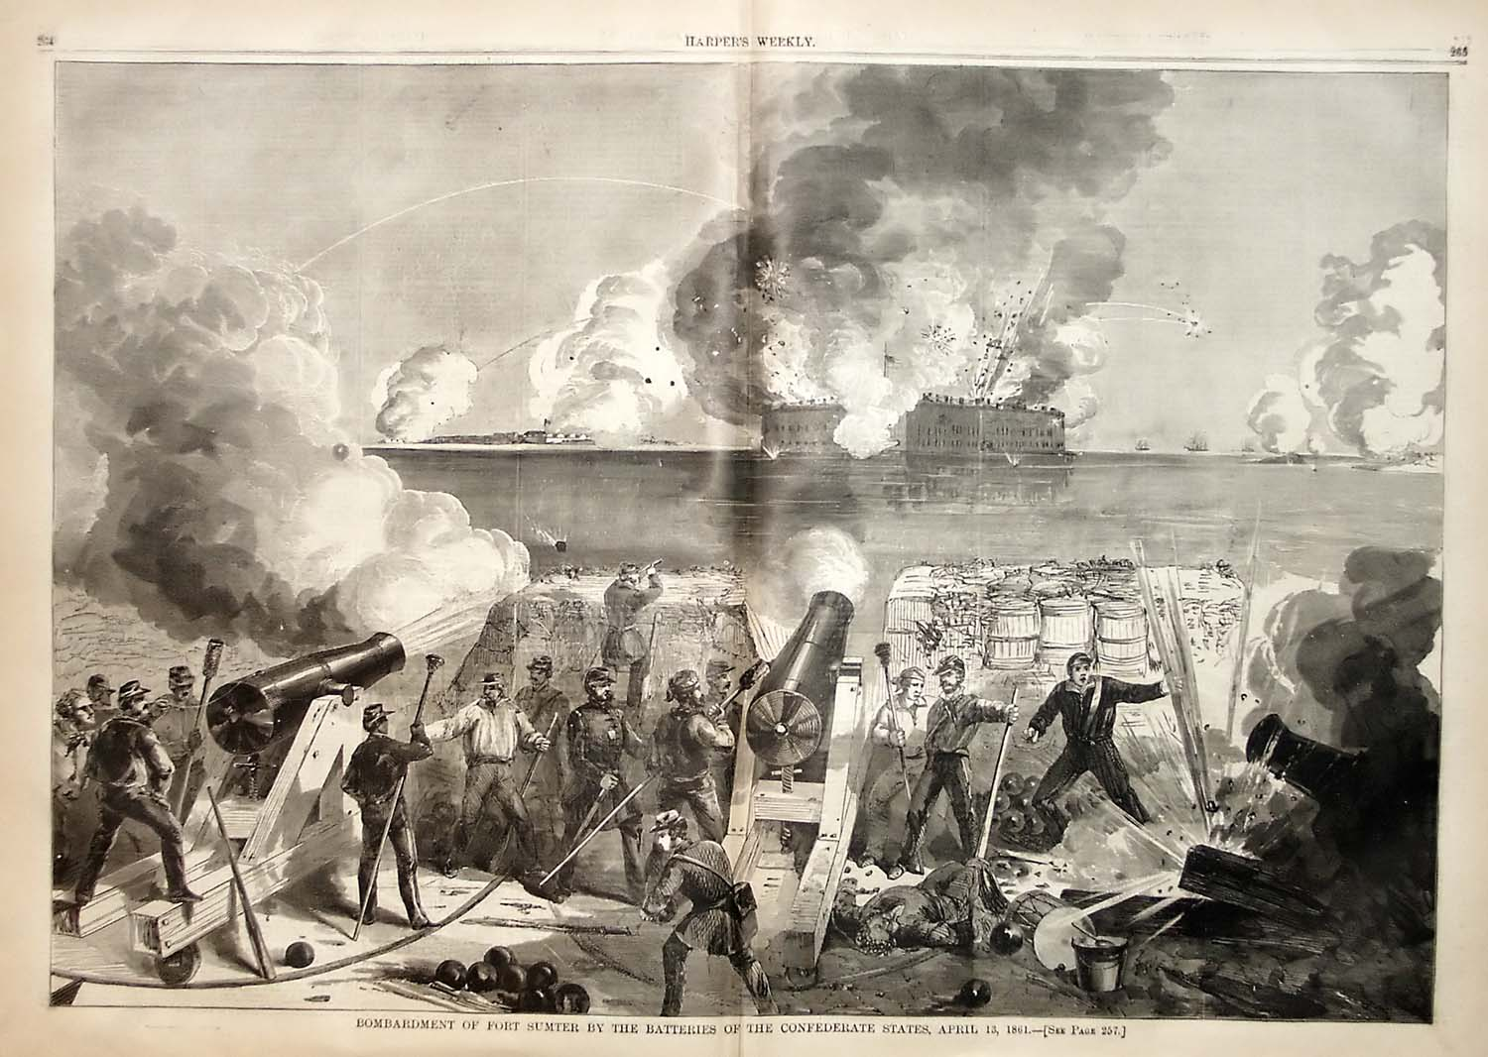
__________________________________________________________
__________________________________________________________
__________________________________________________________

Major Players?
__________________________________________________________
__________________________________________________________
__________________________________________________________
__________________________________________________________

What happened? Effects
____________________________ __________________________
____________________________ __________________________
____________________________ __________________________
____________________________ __________________________

Most Important Terms Most Important People
___________________________ _____________________________

___________________________ _____________________________

___________________________ _____________________________

___________________________ _____________________________

___________________________ _____________________________

Major Issues leading to the Civil War
Directions: Write down two major issues and explain how each led to the nation dividing up to the Civil War.

1. ________________________________________________________
__________________________________________________________
____________________________________________________________________________________________________________________

2. ________________________________________________________
__________________________________________________________
____________________________________________________________________________________________________________________

