Image 1 “Slave Ship”
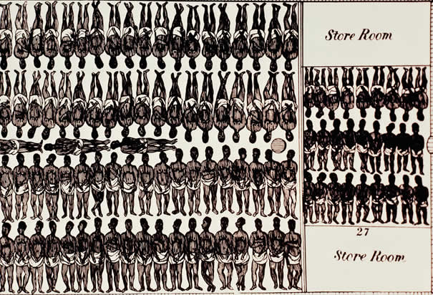

- __________________________________

- __________________________________

- __________________________________

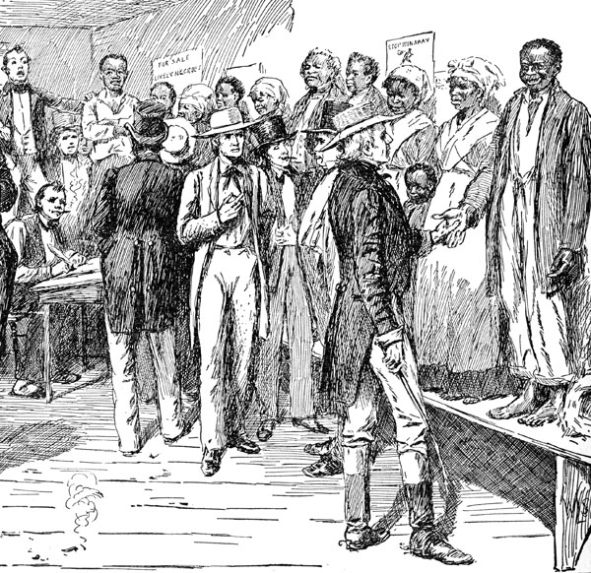

Image 2 “Auction Day”

- __________________________________

- __________________________________

- __________________________________

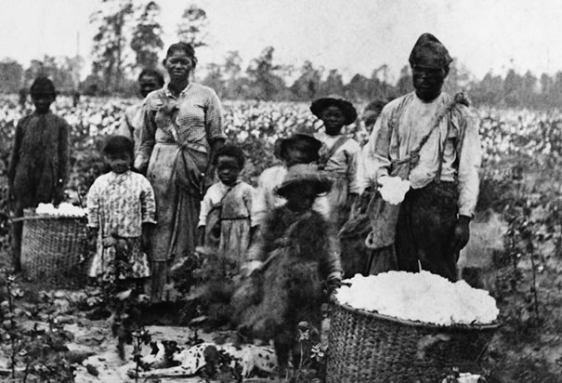

Image 3 “Picking Cotton”

- __________________________________

- __________________________________

- __________________________________

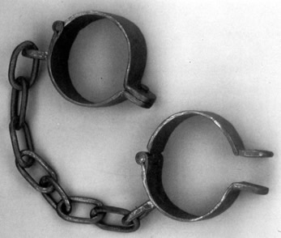

Image 4 “Manacles”

- __________________________________

- __________________________________

- __________________________________

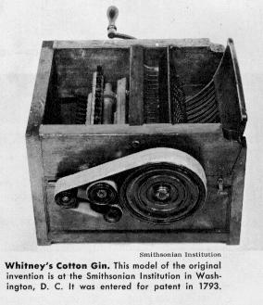

Image 5 “Cotton Gin”

- __________________________________

- __________________________________

- __________________________________

Name:
Photographic Study Notes
Image 6 “Slave’s Back”
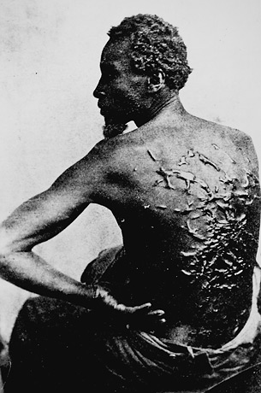

- __________________________________

- __________________________________

- __________________________________

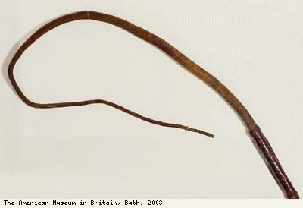

Image 7 “Overseer’s Whip”

- __________________________________

- __________________________________

- __________________________________

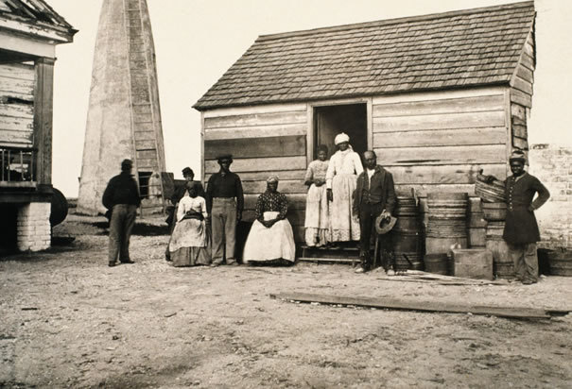

Image 8 “Slave Quarters”

- __________________________________

- __________________________________

- __________________________________

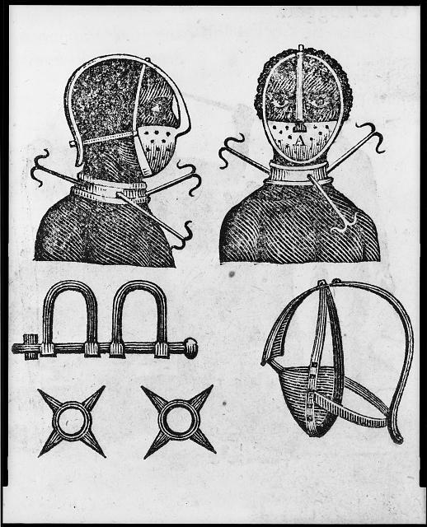

Image 9 and 10 “Collars”

- __________________________________

- __________________________________

- __________________________________

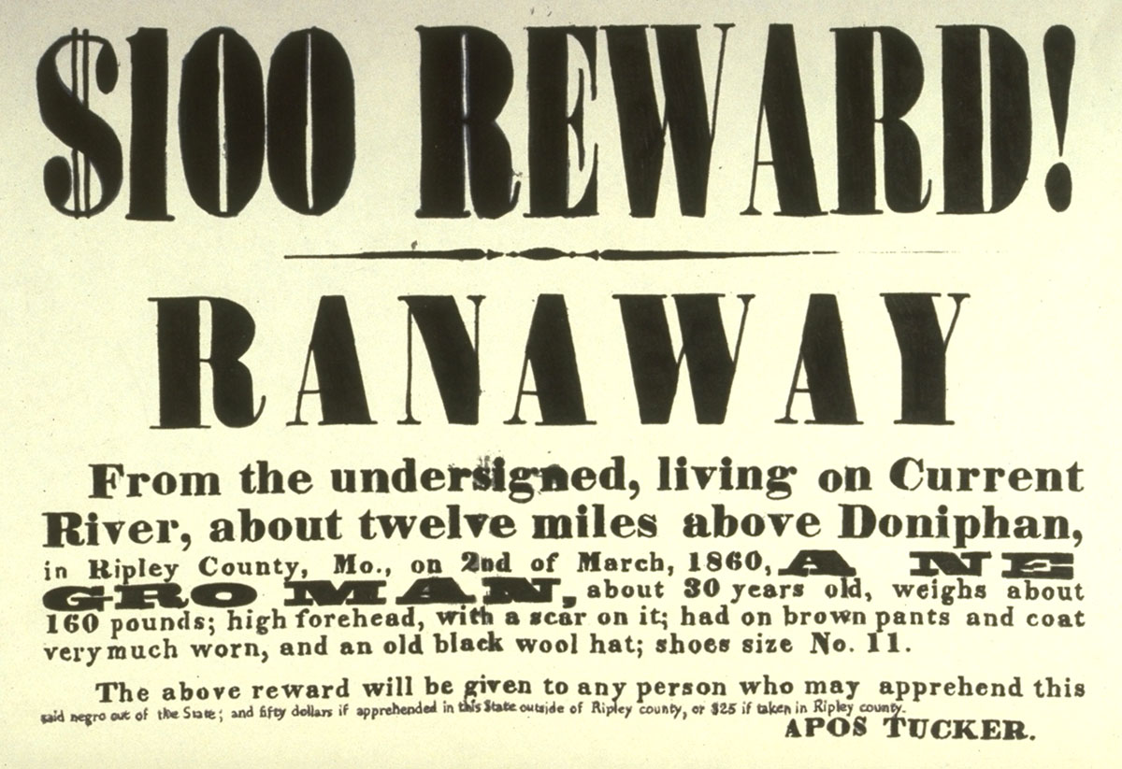

Image 11 “Fugitive Slave Poster”

- __________________________________

- __________________________________

- __________________________________

