Name: _________________________________ Per: ____ Date: _______________
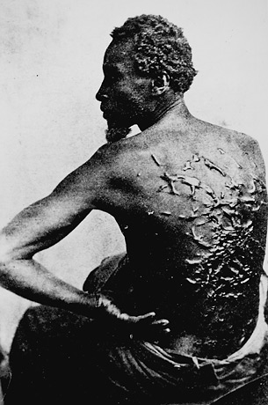
Slavery in America
Study Guide

1. Who, where and when did slavery start in America?
__________________________________________________________________________________________________________________________________________________________________________________________

2. Why were Indians not made slaves?
____________________________________________________________________________________________________________________________

3. Why were Africans made slaves?
__________________________________________________________________________________________________________________________________________________________________________________________

4. Why did white slave owners need slaves? ____________________________________________________________________________________________________________________________

5. Were white people ever slaves?
____________________________________________________________________________________________________________________________

6. Was there slavery in other parts of the world?
____________________________________________________________________________________________________________________________

7. Where was slavery? And Did slave owners outnumber non-slave owners?
__________________________________________________________________________________________________________________________________________________________________________________________

8. How much did the average slave cost?
__________________________________________________________________________________________________________________________________________________________________________________________

9. Why were slave owners cruel?
__________________________________________________________________________________________________________________________________________________________________________________________

10. Why was education illegal for slaves?
____________________________________________________________________________________________________________________________

11. What happened when a slave gets too old to work?
__________________________________________________________________________________________________________________________________________________________________________________________

12. What historic (famous) people were slaves?
__________________________________________________________________________________________________________________________________________________________________________________________

13. How did you (slaves) ask someone about the Underground Railroad?
____________________________________________________________________________________________________________________________

14. How big of an impact did the Underground Railroad have?
__________________________________________________________________________________________________________________________________________________________________________________________

ESSENTIAL QUESTION: Why was slavery evil?

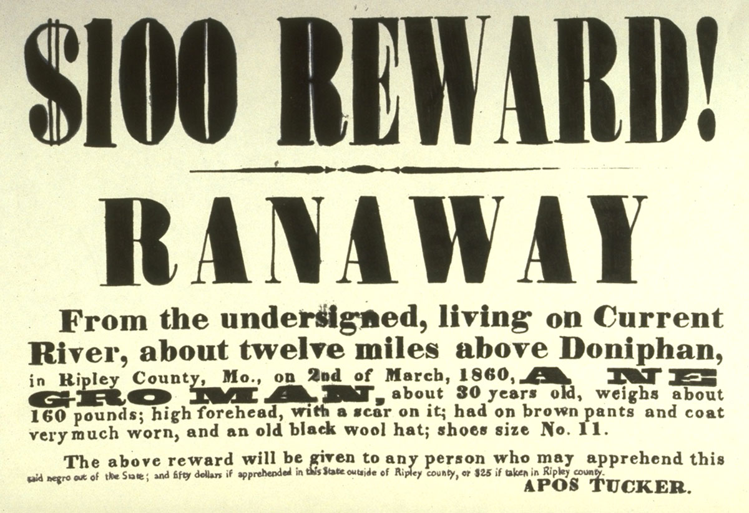
Other Questions to consider for the future:

- How did our nation get up to the point of the Civil War?

- What ended up causing the end of slavery?

- What rights did slaves have after the Civil War?

