Name: _____________________________________________ 2013
Reconstruction (1865-1877)
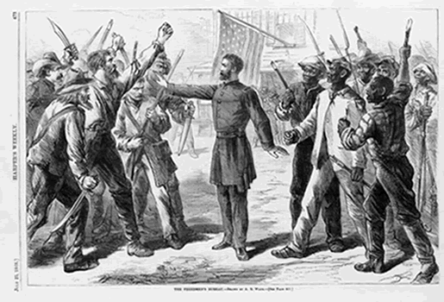
Perspectives on Reconstruction (Point of View)
What side in the Civil War was the song writer on?

What does the author hate?

In the last two stanzas, how will the author act during Reconstruction?
Oh, I'm a good old Rebel soldier, now that's just what I am;
For this "Fair Land of Freedom" I do not give a damn!
I'm glad I fit against it, I only wish we'd won,
And I don't want no pardon for anything I done.

I hates the Constitution, this "Great Republic," too!
I hates the Freedman's Bureau and uniforms of blue!
I hates the nasty eagle with all its brags and fuss,
And the lying, thieving Yankees, I hates 'em wuss and wuss!

Three hundred thousand Yankees is stiff in Southern dust!
We got three hundred thousand before they conquered us.
They died of Southern fever and Southern steel and shot,
But I wish we'd got three million instead of what we got.

I can't take up my musket and fight 'em now no more,
But I ain't a'gonna love 'em, now that's for sartain sure!
I do not want no pardon for what I was and am,
And I won't be reconstructed, and I do not care a damn!
- Written by Major Innes Randolph, C.S.A. (year ?)_

2.
What side in the Civil War was the author on? (Give evidence)

What is the “rightful reward of victory over treason”?

Whose “the rights of individuals” the author is concerned with?
WHETHER THE TREMENDOUS war so heroically fought and so victoriously ended shall pass into history a miserable failure, barren of permanent results … or whether, on the other hand, we shall, as the rightful reward of victory over treason, have a solid nation, entirely delivered from all contradictions and social antagonisms, based upon loyalty, liberty, and equality, must be determined one way or the other by the present session of Congress …
The arm of the Federal government is long, but it is far too short to protect the rights of individuals in the interior of distant States. They must have the power to protect themselves, or they will go unprotected, spite of all the laws the Federal government can put upon the national statute-book. - Written by Frederick Douglass 1866
1.
I. Presidential Reconstruction (1863-1866)
What was the major goal of the president’s plan for Reconstruction?

A. ____________________’s Plan (10% Plan)
TO Rejoin the Union, a Southern state must:
- ________ white Southerners must take a loyalty ______
- New state ________________ must ___________________
- ___________given to most white Southerners who took oath
How did the assassination affect Reconstruction?
B. ASSASINATION
- Abraham Lincoln is __________________ on April 14, 1865
- Many Northerners seek a greater _______________ in South
- President Johnson sets to battle with the ____________________
C. ________________________________
- Lincoln’s _______________________ ( _______term only)
Was there any protection for the freedmen in the president’s plans?
- A former Senator and a “_________________” from ___________________ (a Confederate state!)
- A Southerner who remained ____________to the _________
- Believes the _________________________ class caused secession and the Civil War
- Johnson’s plan is __________________ to Lincoln’s

II. Freedmen in Trouble (1865-1866)
A. Black Codes
1. Laws made in Southern states to restrict _________ _________ AFTER the Civil War
2. Restricted _______________ rights, arrested for ____________crimes such as ________________ and __________________
3. Not allowed to serve on _____________ or be ____________ against white citizens

B. Sharecropping (tenant farmer)
1. white landowner would _________ a shack, land, seed and crude tools to tenant farmer
2. the tenant would _______________ landowner a “share” of the _______________
3. the majority and the tenants lived in conditions ______________ than slavery
How did young freedmen get arrested and put on chain gangs?
Describe details of this freedmen family.
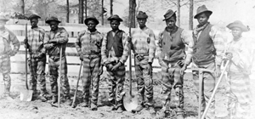
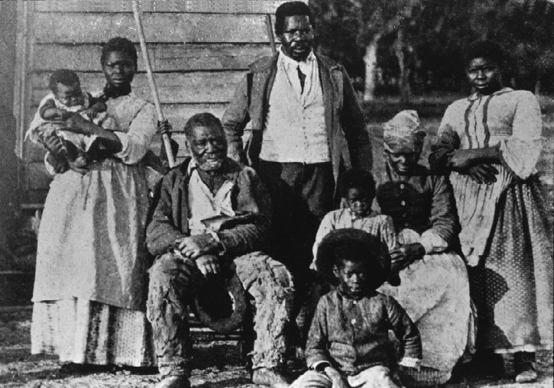

C. Violence
- Groups formed to intimidate freedmen like the _________________ founded by ____________________________________
- White population riots and attacks ___________________ in _________________
and _______________________ (1866)
- Johnson does nothing to protect them
Are freedmen being treated equally? Explain.

III. Radical Reconstruction (1867-1873)
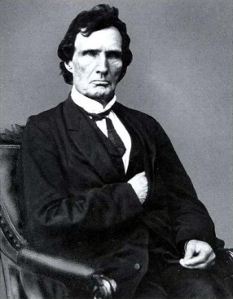
A. Leaders (“Radical” Republicans)
1. _____________________________________
- Leader of “Radicals” in the _________ of Representatives
from Gettysburg, PA
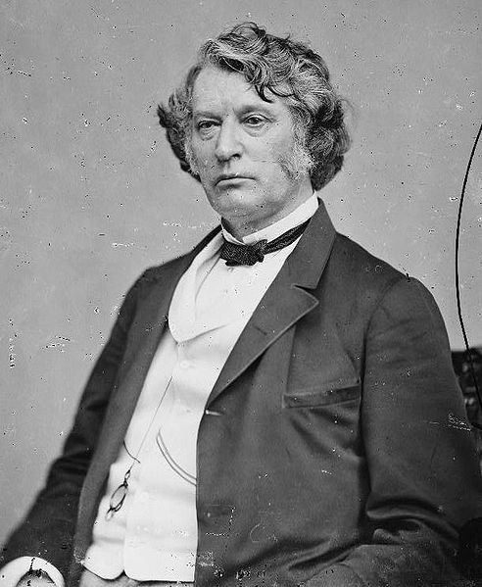
- Hated slavery from his law work in Maryland

2. _____________________________________
- Leader of the ___________________ from Boston, MA
- ________________ in attack in Senate in 1856

3. _____________________________________ “the Beast"
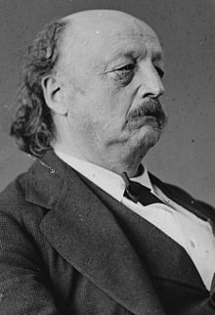
- Civil War general who “reconstructed” ___________________
- Elected in to the House and works for civil rights for freedmen

B. ___________ for the Freedmen
1. ____ th Amendment (1865) - ends slavery
What was “radical” in Radical Reconstruction?

2. _______________________________ (1865)
- a federal agency created to help freedmen _________ to freedom
- _________ by providing food, clothing and medical services
- help get ___________ and find _____________
- set up _________________ and academies
- _________ by President Johnson but is ____________

3. Civil Rights of 1866
- Granted _______ citizenship to African Americans
- Bill is _________ by Johnson but is ___________

4. __________________ V. ___________________!!!

C. _________________________________ of 1867
1. Radical Republicans pass a _________________for Southern states:
- Southern states divided into 5____________ districts ruled by a military commander
- Guaranteed ______________ of African-Americans to vote
- Banned ______________________ leaders from holding office
- Required army to REGISTER ____________ and _____________ freedmen

2. To rejoin nation, Southern states had to:
- Ratify the _____th Amendment (1868)
- Submit _________ constitutions for _____________________ approval

D. Johnson’s ___________________________
- Congress pass laws to ____________________ president
- __________________of Office Act of 1867:
  - Forbid president from __________________ officials without Senate approval
  - Johnson suspended Edwin Stanton from Secretary of War without “approval”
- ________________ of Representatives IMPEACHED the president in March 1868
- Senate held a ___________________ three days later
  - Senate ___________________ president (voted not guilty)
  - Radical Republicans were ________ vote away from 2/3 majority for guilty

E. __________ ____________ Amendments
13th Amendment (Jan 1865)
- _________________________________
14th Amendment (1868)
- People _____________in the U.S. are American ___________________
- Citizens have ______________________
15th Amendment (1870)
- _________________________ males are given the right to __________
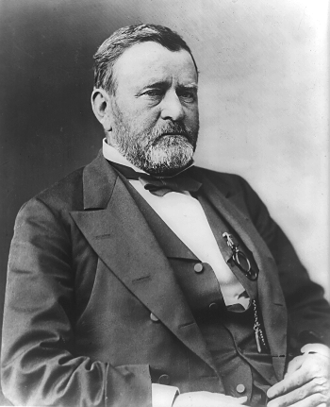
How did Radical Republicans hope to make changes permanently?
Who won between Johnson and the Radicals?
IV. President Ulysses S. Grant

A. Election of 1868
- Ulysses S. ____________ (R-OH) versus
Horatio _________________ (D-NY)
- Grant wins a landslide in the electoral college voting
- Main issue: _____________________________

B. Grant’s Reconstruction Policy
- Supports ______________________ of the freedmen by using the “________ Acts”
- ________________ Radical Reconstruction policies to help rebuild the South

C. Corruption
- _________________________
- Credit Mobilier Scandal (1872)
  - Company uses bribes to get favorable _______________ contracts in the _____
- __________________ Ring (1875)
  - _________ money is “funneled” illegally to whiskey distilleries

- “Carpetbaggers” and “Scalawags”
Southerners link corruption to the Northerners and Republicans in their states
  - ____________________ – Northerner who move South to help Reconstruction
  - ____________________ – Southerners who support Republican policies
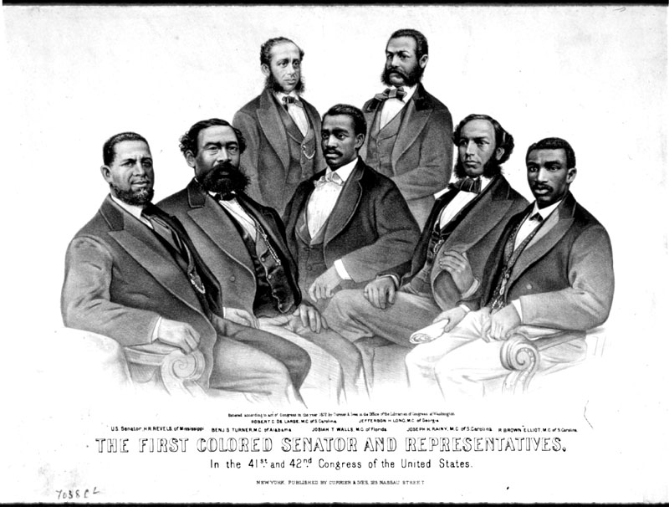

IV. Reconstruction - Successes
A. African Americans Political Leaders
- ______ African-Americans were elected to the House of Representatives
- Hiram _____________ and Blanche K. ___________ were elected ___________ (see p88)
- Never gained control of _______________ governments
- Only ____ African-Americans have ever been a governor of a state or U.S. Senator
How did the South change?
B. Education
1. The ______________________ Bureau
- Established ________________ in the South
- 50% white & 40% black children attended
- Schools were _____________________________
- Most ___________________ were from the ___________________
2. Academies
- Specialized schools to train skills develop into “Black Colleges” such as Fisk (WEB Dubois), Howard (Thurgood Marshall) & Morehouse (Martin L. King)

V. Reconstruction – Failure “The Redeemers” (1873-1875)

A. How did “White Power” get control in South?
1. Amnesty Act of 1872
- Law ___________________ almost ALL ______________ Southerners
- All pardoned could _______________ and HOLD ______________
- _____________________ Party in South regains __________ of state governments (by using majority voting, trickery or terrorism)

2. Election of 1872
- Republican party ____________________ over _____________________
- Grant defeats Horace __________________ (Liberal Repubican)
- Republicans begin to move away from Reconstruction and focus on the __________

3. Panic of 1873 (Panic is another word for Economic Depression)
- Thousands of businesses close and tens of thousands of Americans lose ___________
- ________________________ leaders ________________ for the economy

4. Election of 1876
- Rutheford B. _______________ (R) v. Samuel _________________ (D)
- Tilden _______ the popular vote BUT No CLEAR WINNER in _____________ vote
- Electoral College dispute in _____________ Southern States
- Congress awards all __________elector votes to _____________ making him president
- Hayes makes deal to _____ “Radical” Reconstruction and to pull army out of South

VI. _________________ of Reconstruction (1875-1965)

A. ____________________ Society ( ______________________ )
1. “________________________” seize control Southern States
- Goal is to _________ the _______________ control of their ________ governments

2. Demorcats want to restore “White Power”:
a. Conservative Fiscal Policy:
- Cut state _____________
- lower ___________
- end funding to ______________ and for social policies
b. Voting Restrictions
- ___________________, ___________________, ____________________
c. Jim Crow Laws
- Laws that created a ___________________ society in public places till ______
- “______” and “________” division in schools, restaurants, transportation, etc…

B. Constitutional?
- Local _________________ the abuse of freedmen such as harassment and lynching
- ________________v __________________ (1896)
  - Supreme Court rules that the concept of “separate but ________” as constitutional
- Civil Rights movement fights to end segregation in 1950-1960s
- _______________v ___________________________________ (1954)
- Supreme Court ______ and rules that “separate but equal” as UNCONSTITUTIONAL
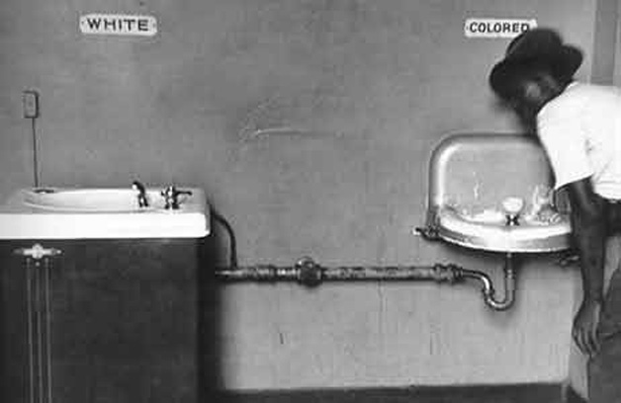
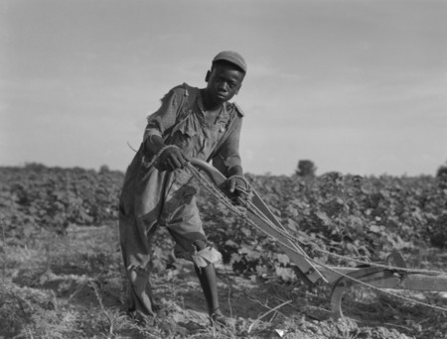

ESSENTIAL QUESTIONS
1. How did the presidents and Radicals plan to unify the nation differ after Civil War?
________________________________________________________________
________________________________________________________________
________________________________________________________________
________________________________________________________________
________________________________________________________________
________________________________________________________________
2. What was Radical Reconstruction?
________________________________________________________________
________________________________________________________________
________________________________________________________________
________________________________________________________________
________________________________________________________________

3. How was “White Power” restored in the Southern states?
________________________________________________________________
________________________________________________________________
________________________________________________________________
________________________________________________________________
________________________________________________________________
________________________________________________________________
________________________________________________________________

4. What was the legacy of Reconstruction? [What were the results/effects?]
________________________________________________________________
________________________________________________________________
________________________________________________________________
________________________________________________________________
________________________________________________________________
________________________________________________________________
________________________________________________________________
________________________________________________________________
________________________________________________________________

