Personal History
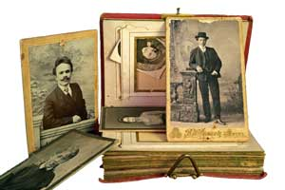

History is a story about a person, place or an event. History is a SCIENCE that requires research. History is also an ART because it tells a story.

The first project in the class will focus on YOU!!!
You will tell the story of your life in the 21st Century.

REFLECT
You will look back at your life and create a list of the major events that matter to you, your family and your community. Hand in exit slip for 10 points.

Ex: Birth Date, First Day of Kindergarten, starting an activity, a sporting
event, or a religious event, etc…

ESP
You will look for five events that took place during your life that would be important in United States or World History. Of the five events, you need one from each of the ESP categories. Also, at least two events need to be CHEERFUL! (One event has to be from each category!) Hand in exit slip for 40 points

E – Economic – events or issues dealing with businesses, money, jobs
S – Social/Cultural – events or issues that deal with how people
interact with one another
P – Political – events or issues that deal with government, laws, or elections

CREATE
You will design a timeline or a brochure to display your significant events in your life and the ESP historical events that you chose. Brochure/Timeline is worth 60 pts

Timeline/Brochure:
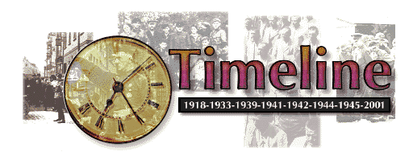
- Your FULL name, your BIRTH date, & PLACE of birth
- Several Images from your life and historical period
- 5 ESP Events including a three to four sentence description
- 10-12 Life events that highlight you talents and important life moments
- Brochure: Need to ORGANIZE life topics by date or topics with titles.
- Timeline: Years measured accurately to scale and be consistent
Ex: 1 inch equals a year OR 2 inches equals a year
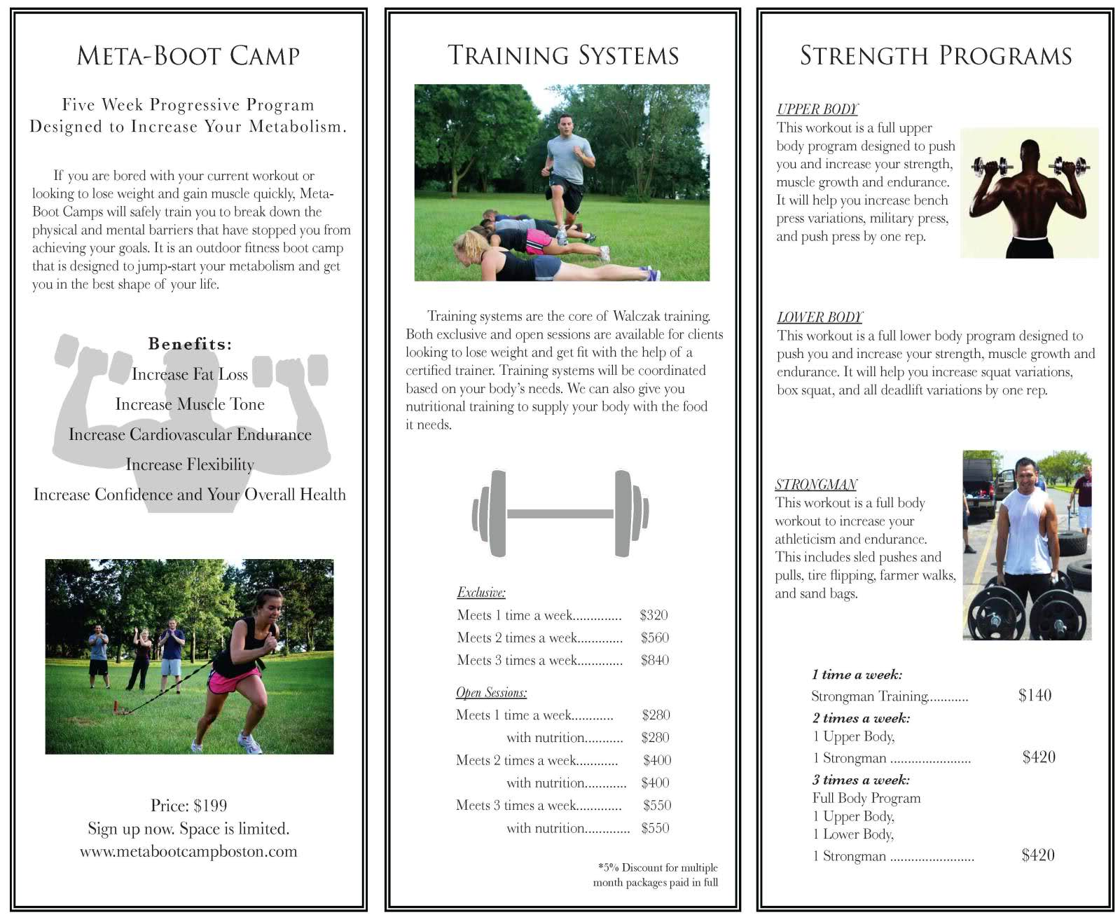
- Neat hand writing or be typed
- LOOK GOOD!!!

GRADING- PROJECT GRADE
Reflection Activity = 10 points
Research ESP Historical Events = 40 points
Brochure/Timeline (Visual Display Rubric) = 60 points
Biography on Classmate = 40 points
Writing a Biography (History)

RESEARCHING A PERSON
(Analyzing evidence from primary & secondary sources)

- Read the timeline of a classmate and pay attention to major events chosen in their life.

- Read the timeline of your classmate and look at the ESP events chosen.

- Feel free to interview the person you are reporting to get necessary information to write your story.

- Brainstorm a list of 6-8 topics you would like to write about this person if you were writing a biography.

WRITE A BIOGRAPHY
Writing an interpretation of the person using evidence.
(Note: The story should not be a list that follows these check marks in their exact order.)

- Write an introductory sentence that highlights the person’s life.

- Write a sentence that includes the time and place the person was born.

- Write a sentence that includes the major hobby, sport, activity the person.

- Write a sentence that connects the person being affected by an ESP event.

- Write other sentences that makes your story work.

- Write a concluding sentence that summarizes the person’s life up to this point.

The introduction and concluding sentence has a SPECIFIC ORDER but the other sentences can be placed in the order you as an author best think.

GRADING BIOGRAPHY
Your biography paragraph will be graded using the constructed response school-wide rubric.

