John Robert Smith, III
About Me
My Personal Life

Basic Facts

I was born in ….

Before Kindergarten

Elementary School

I moved around to many places when I was younger. I attended…

Middle School

I entered Middle School in …

And Beyond

I plan on studying at ….
I dream to become…

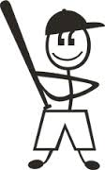

On My Personal Time

ESP Events in my life

2001
September 11th Attacks

In this tragic event, …

2003
Blah, Blah, Blah

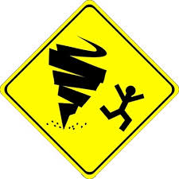

2005
Blah, Blah, Blah

2009
Blah, Blah, Blah

2014
Blah, Blah, Blah

